Week – 10

Character Arrays

Roll no: 240801193

Name: Manju Parkavi

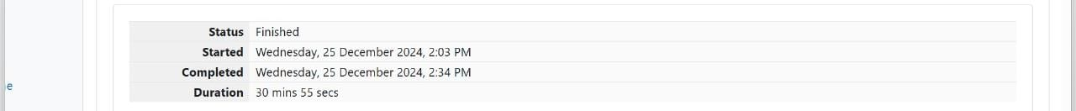

**Problem 1:**

**Input Format**

You are given two strings, a and b, separated by a new line. Each string will consist of

lower-case Latin characters ('a'-'z').

**Output Format**

In the first line print two space-separated integers, representing the length of a and b

respectively.

In the second line print the string produced by concatenating a and b (a + b).

In the third line print two strings separated by a space, a' and b'. a' and b' are the same as

a and b, respectively, except that their first characters are swapped.

**Sample Input**

abcd

ef

**Sample Output**

4 2

abcdef

ebcd af

**Explanation**

a = "abcd"

b = "ef"

|a| = 4

|b| = 2

a + b = "abcdef"

a' = "ebcd"

b' = "af"

**Code:**

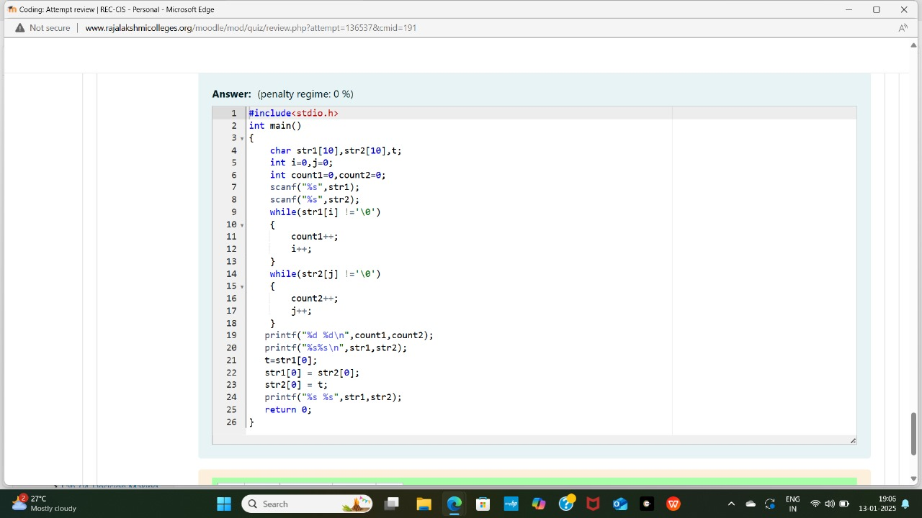

**OUTPUT:**

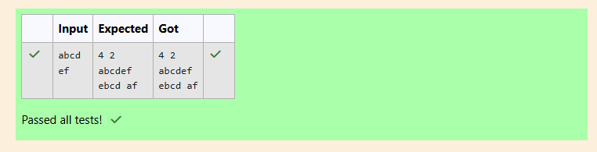

**Problem 2:**

Given a sentence, s, print each word of the sentence in a new line.

**Input Format**

The first and only line contains a sentence, s.

**Constraints**

1 ≤ len(s) ≤ 1000

**Output Format**

Print each word of the sentence in a new line.

**Sample Input**

This is C

Sample Output

This

is

C

**Explanation**

In the given string, there are three words ["This", "is", "C"]. We have to print each of these

words in a new line.

**Hint**

Here, once you have taken the sentence as input, we need to iterate through the input, and

keep printing each character one after the other unless you encounter a space. When a

space is encountered, you know that a token is complete and space indicates the start of

the next token after this. So, whenever there is a space, you need to move to a new line,

so that you can start printing the next token.

**Code:**

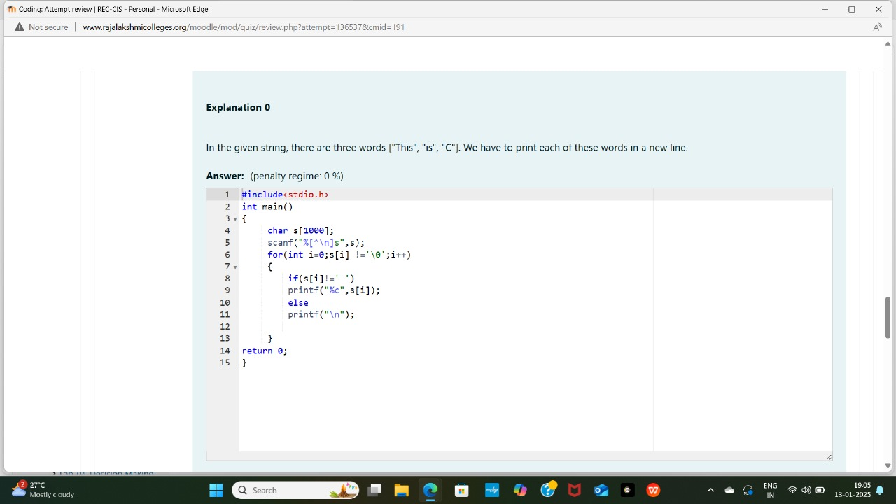

**OUTPUT:**

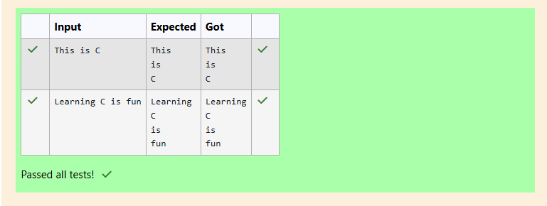

**Problem 3**: Given a string, s, consisting of alphabets and digits, find the frequency of each digit in the

given string.

**Input Format**

The first line contains a string, num which is the given number.

**Constraints**

1 ≤ len(num) ≤ 1000

All the elements of num are made of English alphabets and digits.

**Output Format**

Print ten space-separated integers in a single line denoting the frequency of each digit

from 0 to 9.

**Sample Input 0**

a11472o5t6

**Sample Output 0**

0 2 1 0 1 1 1 1 0 0

**Explanation 0**

In the given string:

• 1 occurs two times.

• 2, 4, 5, 6 and 7 occur one time each.

• The remaining digits 0, 3, 8 and 9 don't occur at all.

Hint:

• Declare an array, freq of size 10 and initialize it with zeros, which will be used to count

the frequencies of each of the digit occurring.

• Given a string, s, iterate through each of the character in the string. Check if the current

character is a number or not.

• If the current character is a number, increase the frequency of that position in the freq

array by 1.

• Once done with the iteration over the string, s, in a new line print all the 10 frequencies

starting from 0 to 9, separated by spaces.

**Code:**

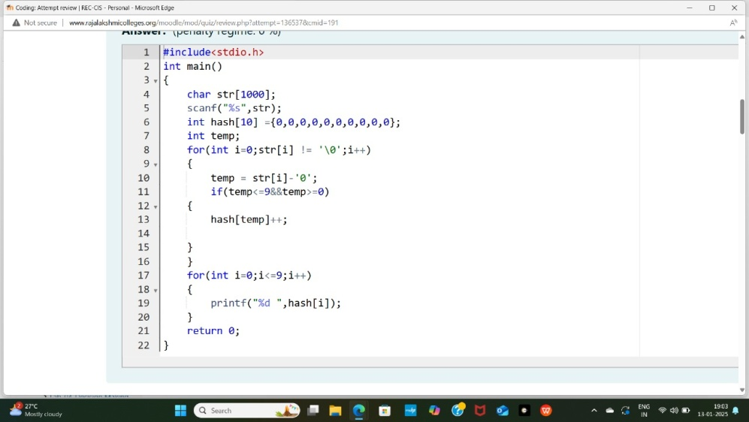

**OUTPUT:  
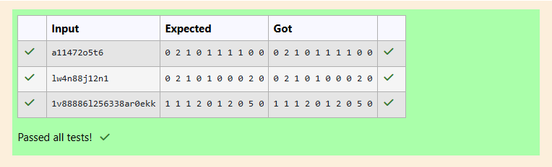**

**Problem 4:** Today, Monk went for a walk in a garden. There are many trees in the garden and each

tree has an English alphabet on it. While Monk was walking, he noticed that all trees with

vowels on it are not in good state. He decided to take care of them. So, he asked you to tell

him the count of such trees in the garden.

Note: The following letters are vowels: 'A', 'E', 'I', 'O', 'U', 'a', 'e', 'i', 'o' and 'u'.

**Input Format:**

The first line consists of an integer T denoting the number of test cases.

Each test case consists of only one string, each character of string denoting the alphabet

(may be lowercase or uppercase) on a tree in the garden.

**Output Format:**

For each test case, print the count in a new line.

**Constraints:**

1 ≤ T ≤ 10

1 ≤ length of string ≤ 105

**Sample Input**

2

nBBZLaosnm

JHkIsnZtTL

**Sample Output**

2

1

**Explanation**

In test case 1, a and o are the only vowels. So, count=2

Brief Description: Given a string S you have to count number of vowels in the string.

Solution 1:

For each vowel, count how many times it is appearing in the string S. Final answer will the

sum of frequencies of all the vowels.

Solution 2:

Iterate overall all the characters in the string S and use a counter (variable) to keep track

of number of vowels in the string S. While iterating over the characters, if we encounter a

vowel, we will increase the counter by 1.

Time Complexity: O(N) where N is the length of the string S. Space Complexity: O(N)

**Code:**

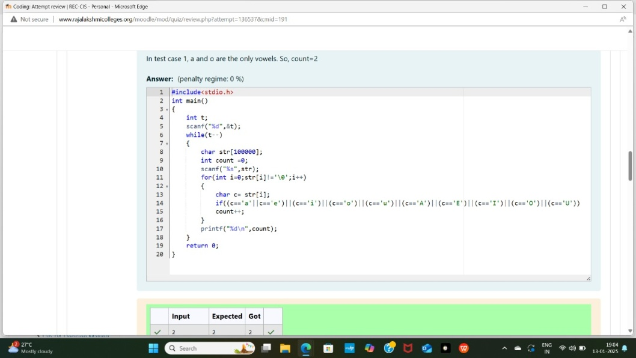

**OUTPUT:**

